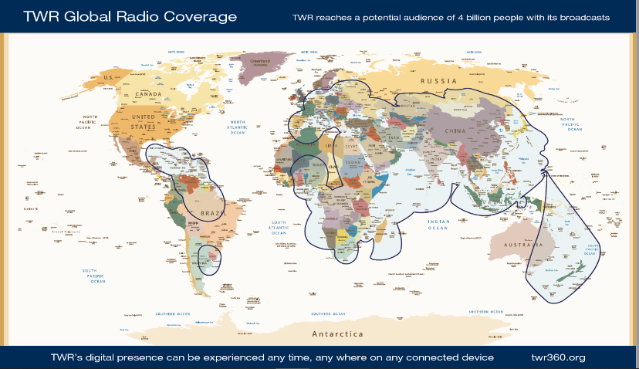
March 2022

Dear Friends and Family,

I am writing to share with you an exciting ministry opportunity for me this coming summer and to ask for your partnership to make it happen. Lord willing, I will be doing an Information Technology internship with TWR International (formerly Trans World Radio) in South Africa. As you may know, I am studying Computer Science and Engineering at Morehead State University but have felt called by God to serve Him in His global ministry to reach a lost world for Christ. To that end, I have applied and been accepted to TWR’s internship program to work with their Technical Services department. I will be helping them strategically organize engineering documents and records in an Engineering Knowledge Hub that can be accessed by TWR engineers worldwide. Additionally, I will be assisting in the implementation and use of Microsoft Software applications and the training of radio operators in Eswatini.

TWR (www.twr.org) is a global media ministry delivering biblical media content in over 300 languages by radio, Internet, mobile phones and mp3 players in over 190 countries. Everyday TWR has the opportunity and privilege of “Speaking Hope to the World” and leading people from “doubt, to decision, to discipleship.” TWR uses media to broadcast the gospel of Christ to people who might not otherwise hear the message of hope. TWR records, translates, contextualizes and broadcasts biblical messages in the heart language of the listener and reaches people in the darkest corners of the earth where missionaries (and sometimes even local pastors) cannot go. As the scripture says:
My word that goes out from My mouth shall not return to Me empty, but it shall accomplish
that which I purpose and shall succeed in the thing for which I sent it. (Isaiah 55:11)

Since TWR is a faith-based mission, I am required to find both prayer partners and financial partners to support this ministry. For this two-month internship, TWR has asked me to find twenty regular prayer partners and to raise a total of $6,274 by May 1st. This financial support will cover my work and travel expenses, rent and utilities, orientation, debriefing and administrative fees and provide me with a modest stipend to pay for my living expenses. To date, God has provided about $1,900 toward my total. So, I would like to ask you to join my prayer team and to prayerfully consider partnering with me financially to make this internship a reality.

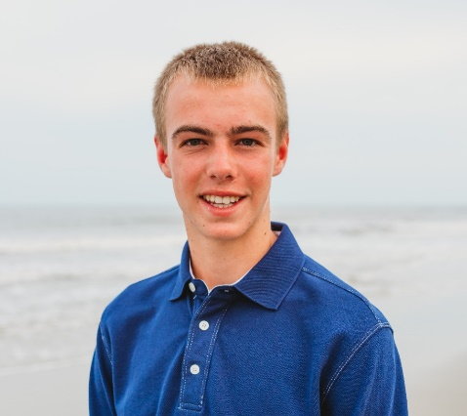
If you would like to partner with me in prayer and/or financial support, please complete the enclosed response slip and mail it back to me. To support my internship financially with a tax-deductible gift, one convenient way is with on-line donation at www.twr.org/vogelpohl. You can also enclose a check or donate by credit card. If you write a check, please make it payable to TWR (noting my name on the memo line only) and mail it to me (not TWR) with the response slip. Thank you in advance and may God richly bless you!

Warmly in Christ,
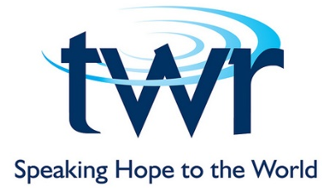
Jacob Vogelpohl

859-240-2959

jt.vogelpohl@icloud.com

135 Andrews Hall
Morehead State University
Morehead, KY 40351

